TAM, SOM, SAM
TAM:
Deep-sea mining: A global addressable market for all marine seabed mineral extraction, offshore mining equipment, and subsea material processing.
Estimated Sizing: $6.18B (2026) $→$ $65.56B (by 2034) at a 34.3% CAGR.
Primary Drivers: Critical battery metal demands (nickel, cobalt, and copper) for the clean energy transition.

Plume Pollution Mitigation: Worldwide total market for marine water discharge treatment, turbidity control, ocean sediment containment, and chemical flocculation systems across all marine engineering, dredging, and offshore extraction platforms.

Primary Drivers: International Seabed Authority (ISA) environmental mandates and global turbidity discharge standards.

SOM:
Deep-sea mining:
Plume Pollution:
SAM:
Deep-sea mining
Plume Pollution:

PESTEL Analysis

Logo
China Logo Design:

Global Logo Design:

Website design (China)
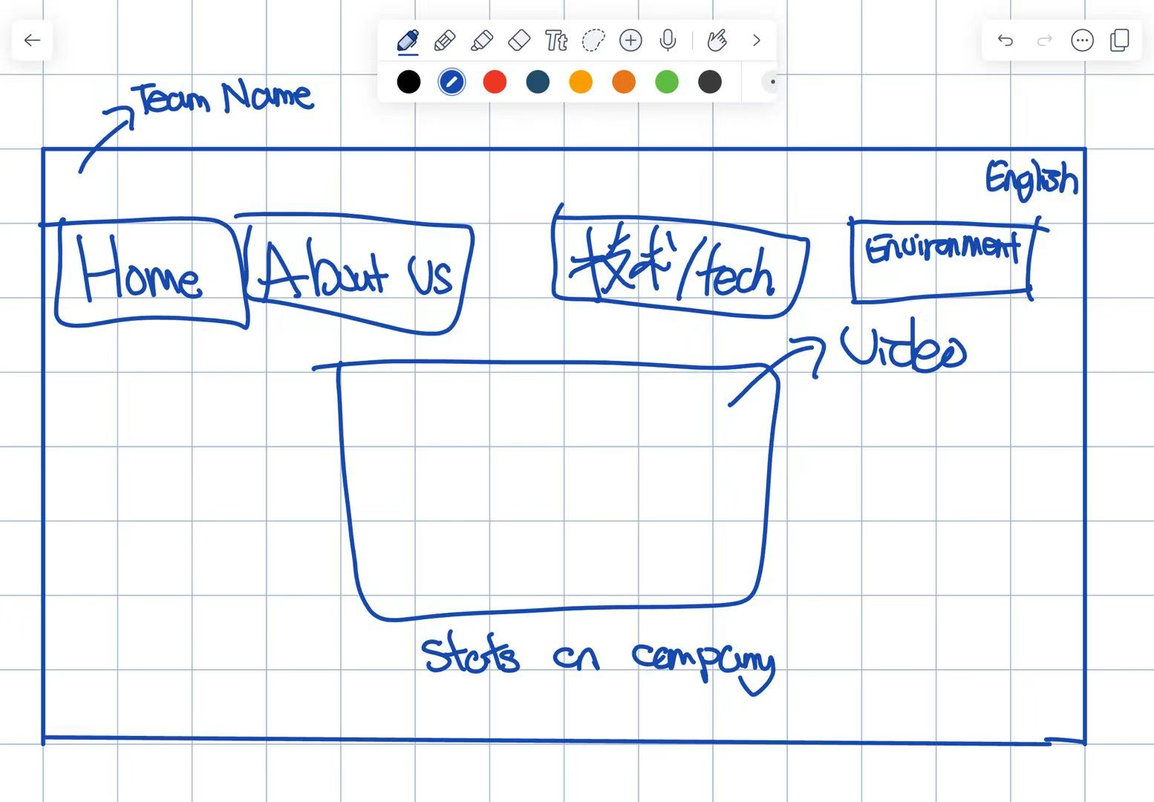

About Us

Inspired by the Sea. Driven by Innovation.

The Story Behind POSEIDON

In ancient Greek mythology, Poseidon was the god of the sea, a symbol of the ocean's immense power, mystery, and influence over the natural world.

Inspired by this legacy, POSEIDON represents our ambition to explore the deep ocean while developing innovative solutions to its environmental challenges. Just as the sea has fascinated humanity for millennia, the deep ocean continues to hold unanswered questions and untapped scientific potential.

Yet exploration must come with responsibility. As human activity extends further into the ocean, we believe that scientific progress should be accompanied by a commitment to protecting marine ecosystems.

For us, POSEIDON is more than a name. It is a reminder of the relationship between humanity, technology, and the natural world — and of our responsibility to ensure that the ocean's future remains sustainable.

What POSEIDON Stands For

Each letter reflects a principle that guides our mission.

P — Protection: Safeguarding marine ecosystems through responsible innovation.

O — Ocean: Placing the ocean at the heart of our research and development.

S — Sustainability: Designing solutions with long-term environmental impact in mind.

E — Exploration: Investigating the deep sea and the challenges that remain unknown.

I — Innovation: Turning scientific ideas into practical, effective solutions.

D — Discovery: Using experimentation and research to deepen our understanding.

O — Observation: Examining environmental changes through evidence and scientific measurement.

N — Navigation: Finding a path towards a more sustainable relationship between technology and the ocean.

Our Mission

The deep sea is one of the least understood environments on Earth, yet it faces growing pressures from human activities.

POSEIDON seeks to bridge the gap between technological innovation and environmental responsibility. Through scientific research, engineering, and experimentation, we aim to develop practical approaches to deep-sea challenges while recognising the complexity and uncertainty of marine ecosystems.

Our goal is not simply to advance what technology can do, but to explore how it can be used more responsibly.

Our Vision

We envision a future in which the exploration of the deep ocean and the protection of its ecosystems can progress together.

By combining curiosity with scientific rigour and innovation with sustainability, POSEIDON aspires to contribute to a future where technological advancement does not come at the expense of the natural world.

The ocean holds the unknown. We work towards a better way to understand and protect it.

Connect With Us

Have a question, an idea, or an opportunity to collaborate? We welcome conversations with fellow innovators, researchers, and people who share our interest in the ocean.

Team: POSEIDON
Email: [Your team email]
Socials: [Your social media links]

Website design (Global)

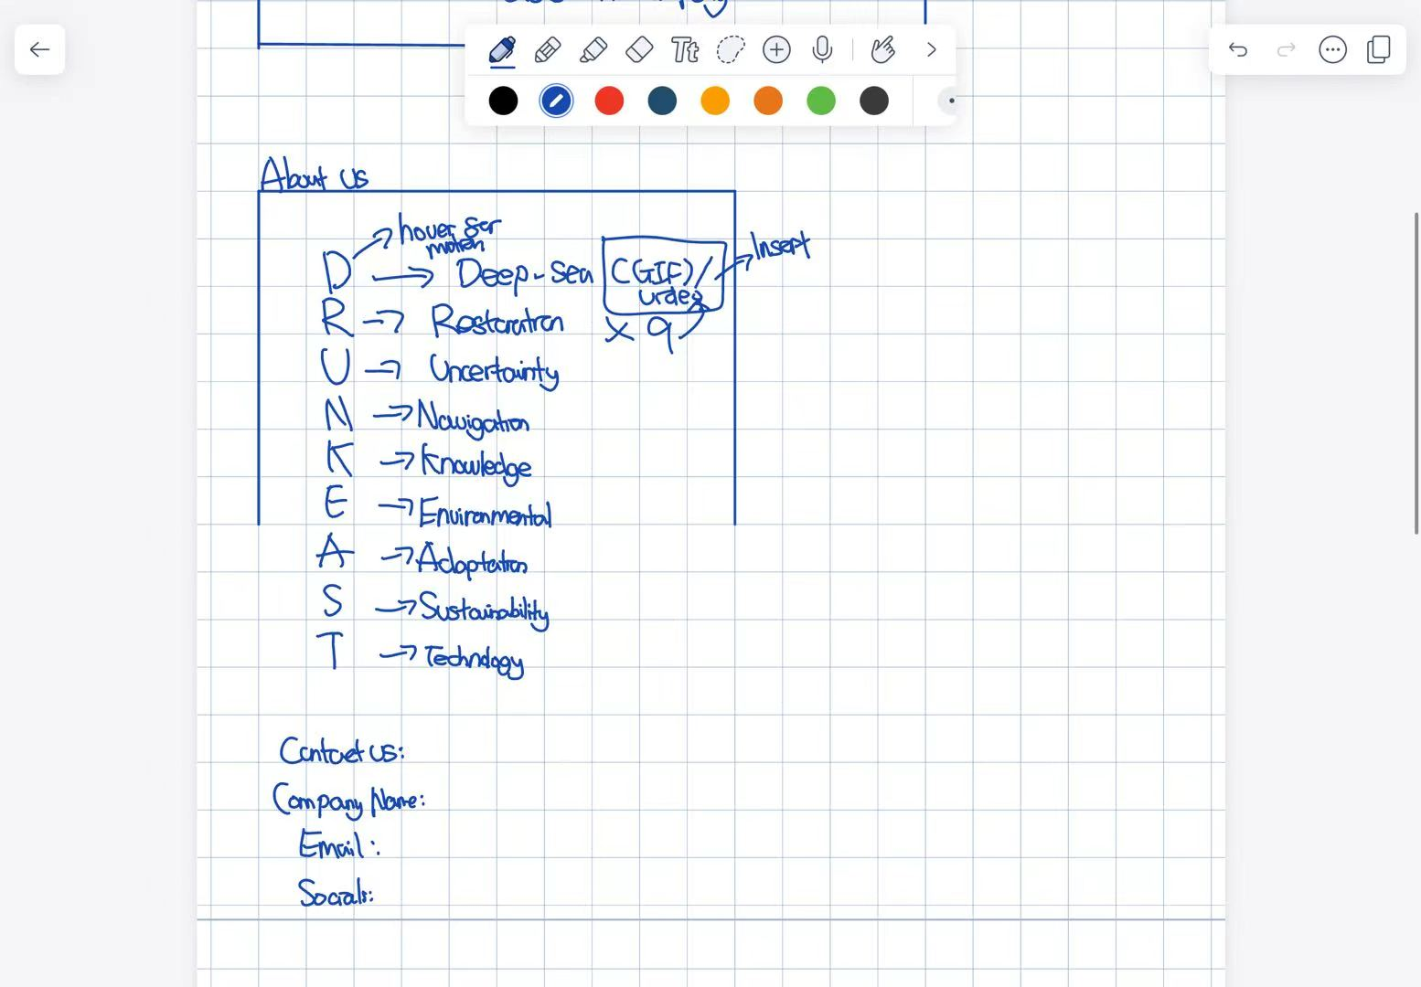

About Us

Who We Are
We are DRUNKEAST, a team driven by curiosity, scientific exploration, and a commitment to the future of our oceans. Working at the intersection of deep-sea research, environmental restoration, and innovative technology, we aim to address the challenges of exploring and protecting one of Earth's least understood environments.
Our name represents the principles that guide our work:
- D — Deep-Sea Exploration: Investigating the mysteries and challenges of the deep ocean.
- R — Restoration: Developing solutions that support the recovery of marine environments.
- U — Uncertainty: Embracing the unknown through research, experimentation, and critical thinking.
- N — Navigation: Finding pathways through complex scientific and environmental challenges.
- K — Knowledge: Turning research and evidence into informed decisions.
- E — Environmental Protection: Prioritising the health and resilience of marine ecosystems.
- A — Adaptation: Responding to changing conditions with flexible, innovative solutions.
- S — Sustainability: Balancing technological progress with long-term environmental responsibility.
- T — Technology: Applying science and engineering to tackle real-world problems.

Our Mission
We believe that innovation should go hand in hand with environmental responsibility. Our mission is to explore practical, science-based approaches to deep-sea challenges, combining technological development with a commitment to sustainability.
By questioning existing approaches, testing new ideas, and learning from the natural world, we strive to contribute to a future in which ocean exploration and environmental protection can advance together.

Get in Touch
Have a question, an idea, or an opportunity to collaborate? We would love to hear from you.
Company Name: DRUNKEAST
Email: teamdrunkeast@gmail.com (registered)
Social Media: [Your social media links]

The Technology and Innovation Behind our product:

On Sustainability:

Lean Canvas (China)
POSEIDON:

3. Opportunity (300 words): What issue or pain point does the innovation address?

6. Market (300 words): Describe the customer and the target segments. What is important to them? What is the size of the opportunity? Is the buyer or payer different from the customer in this market? Describe the industry ecosystem

The primary target market consists of marine environmental engineering firms, private and state contractors as well as municipal enviornmental protection organizations such as the ISA can use to adapt to the solution and to set it as a regulatory framework in order to reach net zero emissions. Secondary segments include offshore energy operators and eco-tourism developers requiring sustainable shoreline stabilization. The three important factors to these consumers will be the regulatory compliance and eco safety by non-toxic chemical residuals in marine protection zones, performance and derability, and the carbon footprint of achieving net-zero by 2030.

Lean Canvas (Global)
DRUNKEAST:

Promo Video

Porter Analysis

